1. Create the VPC
In AWS Console:
AWS Console → VPC → Your VPCs → Create VPC
Choose:
- Resources to create: VPC only
- Name tag: InstaVibeVPC
- IPv4 CIDR: 10.0.0.0/16
- IPv6: No IPv6 CIDR block
- Tenancy: Default

2. Create the two subnets
Go to:
VPC → Subnets → Create subnet
Public subnet
- VPC: InstaVibeVPC
- Subnet name: PublicSubnet-Zomato
- Availability Zone: Choose any one
- IPv4 CIDR: 10.0.1.0/24
Create it.
Private subnet
Create another subnet:
- VPC: InstaVibeVPC
- Subnet name: PrivateSubnet-Zomato
- Same or another Availability Zone
- IPv4 CIDR: 10.0.2.0/24
Create it.

3. Create the Internet Gateway
Go to:
VPC → Internet Gateways → Create internet gateway
Name it:
InstaVibe-IGW
Click Create internet gateway.
Then select it → Actions → Attach to a VPC
Select:
InstaVibeVPC

4. Create the Public Route Table
Go to:
VPC → Route Tables → Create route table
Name:
PublicRouteTable-Zomato
VPC:
InstaVibeVPC
Create it.
Then select the route table → Routes → Edit routes → Add route
Enter:
Destination | Target
0.0.0.0/0 | Internet Gateway → InstaVibe-IGW
Save changes.

5. Associate the public subnet
With PublicRouteTable-Zomato selected:
Subnet associations → Edit subnet associations
Select:
PublicSubnet-Zomato
Save.
Now the traffic path is:
PublicSubnet → PublicRouteTable → Internet Gateway → Internet

6. Create the Private Route Table
Create another route table:
VPC → Route Tables → Create route table
Name:
PrivateRouteTable-Zomato
VPC:
InstaVibeVPC
Create it.
Then:
Subnet associations → Edit subnet associations
Select:
PrivateSubnet-Zomato
Save.
7. Diagram for your assignment
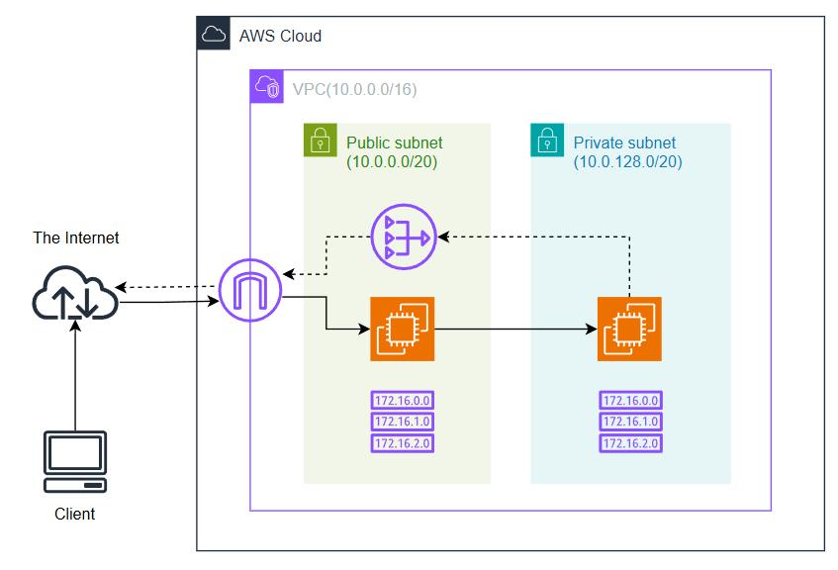
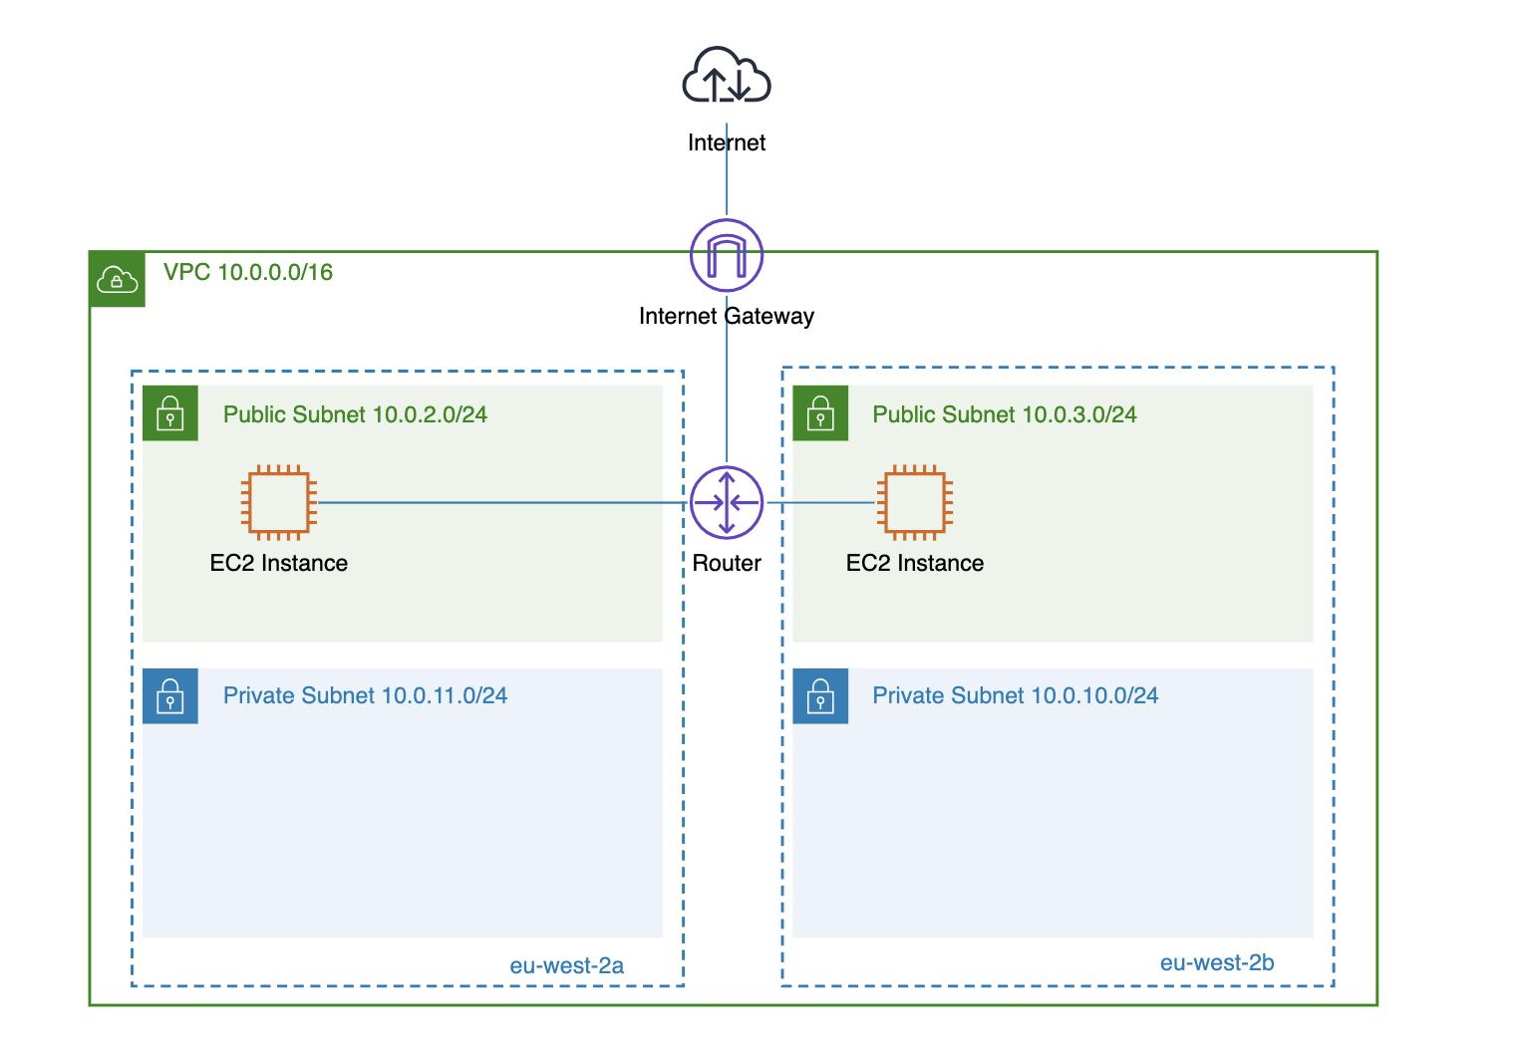
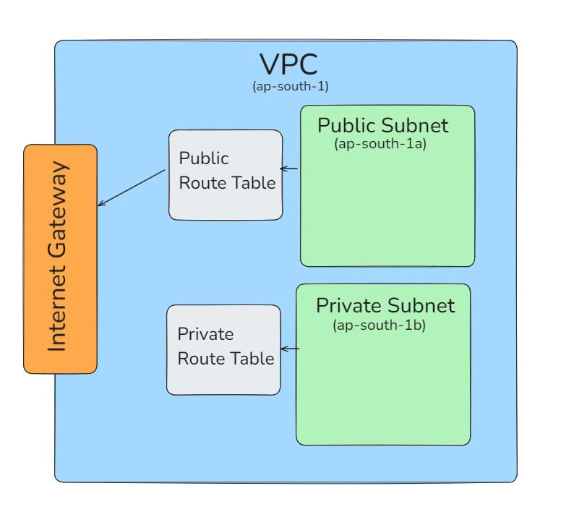
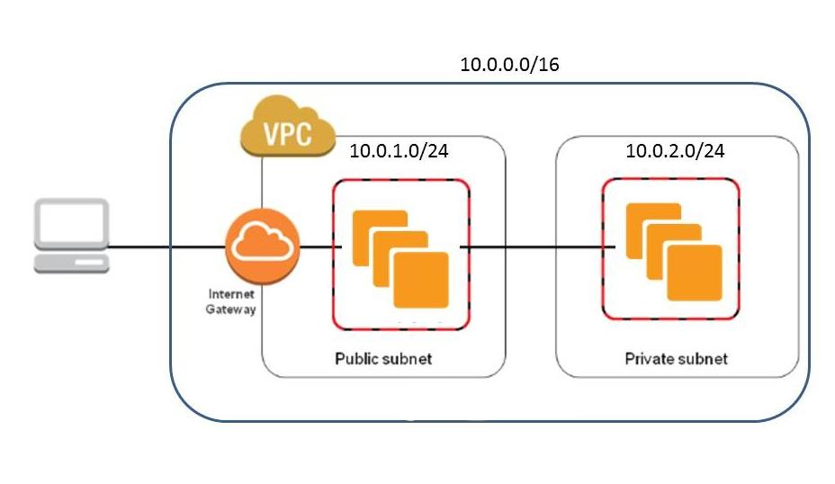
For your diagram, include these exact labels:
- InstaVibeVPC
- 10.0.0.0/16
- PublicSubnet-Zomato
- 10.0.1.0/24
- PrivateSubnet-Zomato
- 10.0.2.0/24
- PublicRouteTable-Zomato
- PrivateRouteTable-Zomato
- Internet Gateway
8. 3–4 line explanation to submit
The VPC separates the application into public and private network areas. The public subnet can communicate with the internet through the Internet Gateway and can host web servers. The private subnet does not have a direct route to the Internet Gateway and can be used for backend services or databases. This is similar to applications like Zomato, where the public-facing application is separated from private backend and database systems for better security.

